EFT (Emotional Freedom Technique) or Tapping
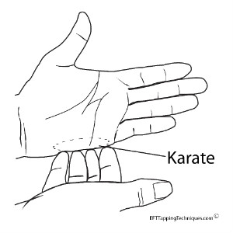
- Identify the problem or issue and give it a score on a scale of 1- 10 (1 being hardly noticeable, 10 being as strong as it could be

- Set Up -Tapping on the ‘Karate chop’ point

- “Even though (I have this problem ) ________________ I completely Love and accept myself anyway”
- “Even though I have this feeling __________________ I accept who I am and how I feel”
- “Even though I feel this so strongly I completely accept myself anyway”

- Tap round each of these points, naming each aspect of how you feel

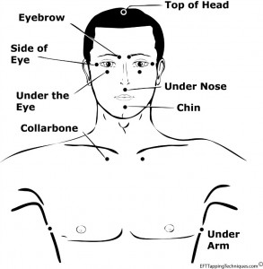

4.Check in with what you notice, has anything changed / moved? Take a breath and continue around the points using phrases like “ this remaining pain/ feeling/ issue”

5. Take a breath, and check in again – notice if the scoring has changed, and if anything else has arisen that you’d like to add in or focus on. Go back to no.1 and keep going through each step.

© Hannah Currant www.hannahcurrantshiatsu.org.uk
Hannah@hannahcurrantshiatsu.org 07981992178
Offering 1:1 Support, in person or by Skype, Workshops and short courses

Additional tips:

When ‘tuning into’ the issue / problem / difficulty – explore where you might feel that in your body;

- Does it have a physical sensation? (i.e. a tightness in the chest)

- A direction of movement? (i.e. a churning in the stomach / a rising feeling in the throat )

- See if you can give it a colour / texture/ form and add that into your description as you tap around the points.

- Keep switching between the physical and emotional sensations. If anything shifts or changes or arises – add that in.

Once you’ve done a few rounds on what you’re feeling – you can give some attention to what you’d LIKE to feel

See if you can clarify what that might be and how it might feel (ie a sense of peace and spaciousness / calm and loving etc)

Begin to add this into the tapping with sentences like:

I choose to feel calm about this
I choose to be surprised at how easily I can let this go
I allow myself to be peaceful around this

And notice what the ‘Yes but’s” are, and build them in! (they’ll conveniently pop up! Turn the volume up and bring them in!)

You can alternate between the positive and the negative and keep checking in with the original set up statement, and how strong it feels in relation to where you began, and if anything else has arisen feel free to follow that.

If it’s a strong reaction / thought / feeling again give it a scale from 1 – 10 and keep going! There’s no getting it wrong – just keep naming whatever comes up and keep tapping!

Enjoy and good luck!

© Hannah Currant www.hannahcurrantshiatsu.org.uk
Hannah@hannahcurrantshiatsu.org 07981992178
Offering 1:1 Support, in person or by Skype, Workshops and short courses

